Exposed boundaries in a tilemap

Case 1: Tiles are either solid or empty

In our simplified game all of our tilemaps will be made from rectangular tiles. Let’s first suppose that all we can have are either a full, solid tile with all of its 4 boundaries, or an empty tile with no boundaries. No slopes, and no semisolids. When we take one tile as isolated, all 4 boundaries will be exposed. So, if this tile is deemed as solid, any movement may have to check the 4 of them.

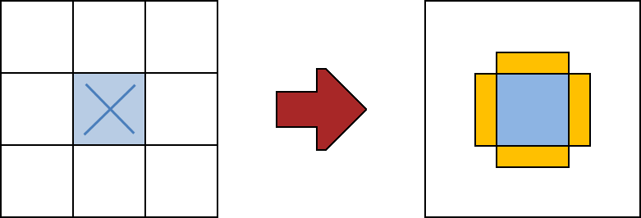

However, when a tile has adjacent neighbours, it would not be correct to collide with non-exposed block boundaries. In this second case, for example, doing that may make the player stop when walking. To prevent that, we first check which of the tile boundaries are exposed and check for collisions only on those.

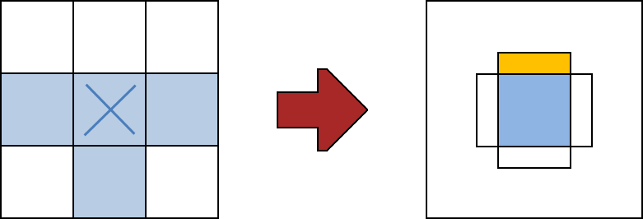

In fact, in this last case, the marked tile (even if solid) cannot collide with the player at all! Any movement will always encounter some of the neighbor tiles tiles first.

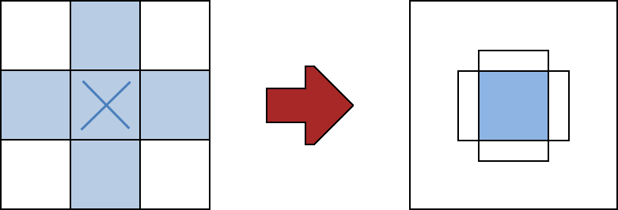
Case 2: Implementing semisolids

While a platformer game can work with only solid tiles, it is very common to at least implement “semisolids”, which are tiles where the 4 boundaries can be treated differently. The most usual case is a “bridge tile” that allows our character to jump from below, but won’t let it fall when coming from above.

However, this creates more complex cases when looking for possible collisions. Consider that you combine 2 semisolids in a way similar to this (a situation which actually happens in our game):

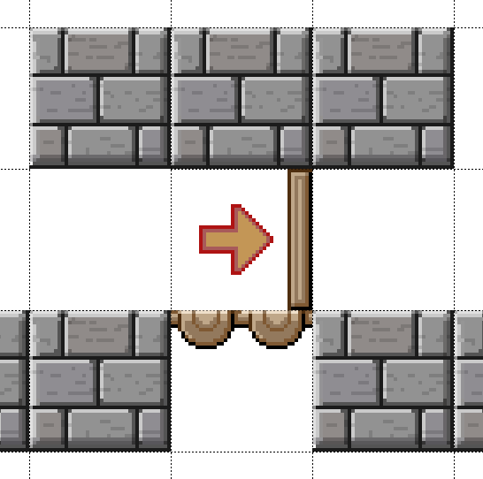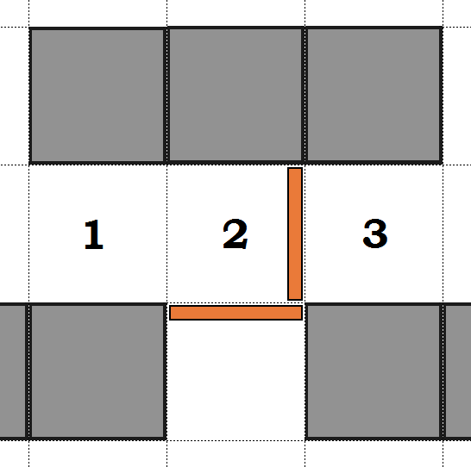

In this case, when should we consider the top boundary for the bridge as “exposed” and check it? It turns out that now this is going to depend on player position along X axis. If the player collision box is entirely at the right of the vertical boundary (region 3), it can never collide with the bridge. However, if the player overlaps with regions 1 or 2, collision with the bridge must be applied.

